Task Sheet

Task 1 – You will need to have your recipes.
Task 2 – Log on onto the following website:
www.nutritionprogram.co.uk/login
The teacher will have your login and password details.
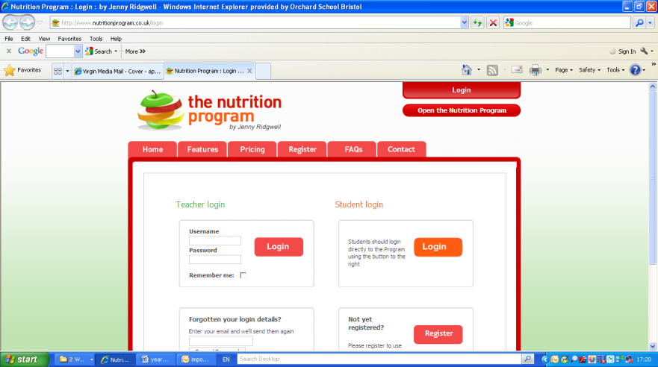
Log on here!

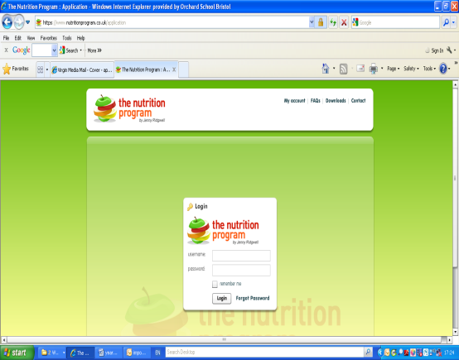
Insert your User Name and password

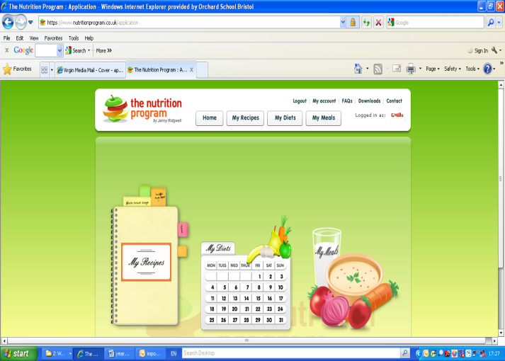
Task 3 – Using this page you can investigate what the website allows you to do.

By Clicking on create new recipe you can now add new recipe and insert each recipe one at a time.
e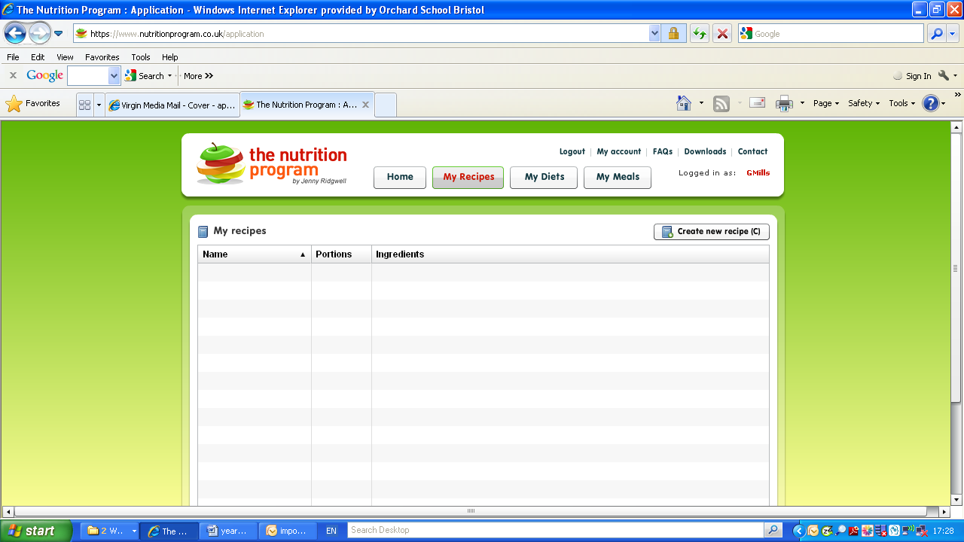

Task 4 – Ensure you enter the correct amounts and correct ingredients (Ask if you are unsure)

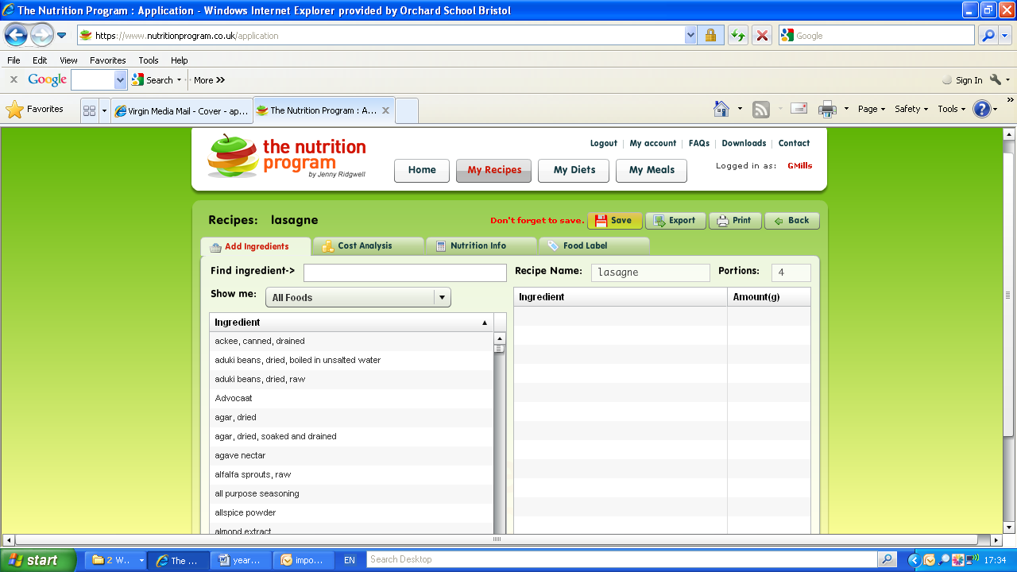
Shows you the cost of ingredients you have selected for your product.
You can select what Nutritional information you are interested in
You can click on here which allows you to create a food label and upload images.
Here is where you add ingredients to your recipe

Task 6 – you need to take a screen shot of each of the four recipes so you can annotate the nutrition at a later date and paste into a word document.

Task 7 – Ensure you print the costing or screen shot and paste into a word document.

